

BOOK CLUB MANAGEMENT SYSTEM

A PROJECT REPORT
Submitted by

MOHAMED KYUF R (2303811714821016)

in partial fulfillment of requirements for the award of the course
CGB1221-DATABASE MANAGEMENT SYSTEMS
in

ARTIFICIAL INTELLIGENCE AND MACHINE LEARNING

K. RAMAKRISHNAN COLLEGE OF TECHNOLOGY
(An Autonomous Institution, affiliated to Anna University Chennai and Approved by AICTE, New Delhi)

SAMAYAPURAM – 621 112

JUNE- 2025

K. RAMAKRISHNAN COLLEGE OF TECHNOLOGY
(AUTONOMOUS)
SAMAYAPURAM – 621 112

BONAFIDE CERTIFICATE

Certified that this project report on “ Book club management system” is the bonafide work of MOHAMED KYUF R (2303811714821016) who carried out the project work during the academic year 2024 - 2025 under my supervision.
 | 
SIGNATURE  Dr.T.AVUDAIAPPAN, M.E.,Ph.D.,  HEAD OF THE DEPARTMENT  ASSOCIATE PROFESSOR  Department of Artificial Intelligence  K.Ramakrishnan College of Technology (Autonomous)  Samayapuram–621112. | SIGNATURE  Mr.R.ROSHAN JOSHUA, M.E.,  SUPERVISOR  ASSISTANT PROFESSOR  Department of Artificial Intelligence  K.Ramakrishnan College of Technology (Autonomous)  Samayapuram–621112.

Submitted for the viva-voce examination held on …04.06.2025……………….

INTERNAL EXAMINER | EXTERNAL EXAMINER
DECLARATION

I declare that the project report on “Book club management system” is the result of original work done by us and best of our knowledge, similar work has not been submitted to “ANNA UNIVERSITY CHENNAI” for the requirement of Degree of BACHELOR OF ENGINEERING. This project report is submitted on the partial fulfilment of the requirement of the completion of the course CGB1221 – DATABASE MANAGEMENT SYSTEMS.

Signature

Name of the Student

Place: Samayapuram

Date:04/06/20025

ACKNOWLEDGEMENT

It is with great pride that I express our gratitude and in-debt to our institution “K.Ramakrishnan College of Technology (Autonomous)”, for providing us with the opportunity to do this project.

I glad to credit honourable chairman Dr. K. RAMAKRISHNAN, B.E., for having provided for the facilities during the course of our study in college.

I would like to express our sincere thanks to our beloved Executive Director Dr. S. KUPPUSAMY, MBA, Ph.D., for forwarding to our project and offering adequate duration in completing our project.

I would like to thank Dr. N. VASUDEVAN, M.Tech., Ph.D., Principal, who gave opportunity to frame the project the full satisfaction.

I whole heartily thanks to Dr. T. AVUDAIAPPAN, M.E.,Ph.D., Head of the department, ARTIFICIAL INTELLIGENCE for providing his encourage pursuing this project.

I express our deep expression and sincere gratitude to our project supervisor Mr.R.ROSHAN JOSHUA, M.E., Department of ARTIFICIAL INTELLIGENCE, for his incalculable suggestions, creativity, assistance and patience which motivated us to carry out this project.

I render our sincere thanks to Course Coordinator and other staff members for providing valuable information during the course.

I wish to express our special thanks to the officials and Lab Technicians of our departments who rendered their help during the period of the work progress.

INSTITUTE
Vision:
- To serve the society by offering top-notch technical education on par with global standards.
Mission:
- Be a center of excellence for technical education in emerging technologies by exceeding the needs of industry and society.
- Be an institute with world class research facilities.
- Be an institute nurturing talent and enhancing competency of students to transform them as all – round personalities respecting moral and ethical values.

DEPARTMENT
Vision:

- To become a renowned hub for AIML technologies to producing highly talented globally recognizable technocrats to meet industrial needs and societal expectation.

Mission

- To impart advanced education in AI and Machine Learning, built upon a foundation in Computer Science and Engineering.
- To foster Experiential learning equips students with engineering skills to tackle real-world problems.
- To promote collaborative innovation in AI, machine learning, and related research and development with industries.
- To provide an enjoyable environment for pursuing excellence while upholding strong personal and professional values and ethics.

PROGRAM EDUCATIONAL OBJECTIVES (PEO)

- PEO1: Excel in technical abilities to build intelligent systems in the fields of AI & ML in order to find new opportunities.
- PEO2: Embrace new technology to solve real-world problems, whether alone or as a team, while prioritizing ethics and societal benefits.
- PEO3: Accept lifelong learning to expand future opportunities in research and product development.

PROGRAM SPECIFIC OUTCOMES (PSO)
- PSO1: Expertise in tailoring ML algorithms and models to excel in designated applications and fields.
- PSO2: Ability to conduct research, contributing to machine learning advancements and innovations that tackle emerging societal challenges.

PROGRAM OUTCOMES (POs)
Engineering students will be able to:
- Engineering knowledge: Apply the knowledge of mathematics, science, engineering fundamentals, and an engineering specialization to the solution of complex engineering problems.
- Problem analysis: Identify, formulate, review research literature, and analyze complex engineering problems reaching substantiated conclusions using first principles of mathematics, natural sciences, and engineering sciences
- Design/development of solutions: Design solutions for complex engineering problems and design system components or processes that meet the specified needs with appropriate consideration for the public health and safety, and the cultural, societal, and environmental considerations
- Conduct investigations of complex problems: Use research-based knowledge and research methods including design of experiments, analysis and interpretation of data, and synthesis of the information to provide valid conclusions
- Modern tool usage: Create, select, and apply appropriate techniques, resources, and modern engineering and IT tools including prediction and modeling to complex engineering activities with an understanding of the limitations
- The engineer and society: Apply reasoning informed by the contextual knowledge to assess societal, health, safety, legal and cultural issues and the consequent responsibilities relevant to the professional engineering practice
- Environment and sustainability: Understand the impact of the professional engineering solutions in societal and environmental contexts, and demonstrate the knowledge of, and need for sustainable development
- Ethics: Apply ethical principles and commit to professional ethics and responsibilities and norms of the engineering practice.
- Individual and team work: Function effectively as an individual, and as a member or leader in diverse teams, and in multidisciplinary settings.
- Communication: Communicate effectively on complex engineering activities with the engineering community and with society at large, such as, being able to comprehend and write effective reports and design documentation, make effective presentations, and give and receive clear instructions.
- Project management and finance: Demonstrate knowledge and understanding of the engineering and management principles and apply these to one’s own work, as a member and leader in a team, to manage projects and in multidisciplinary environments.
- Life-long learning: Recognize the need for, and have the preparation and ability to engage in independent and life-long learning in the broadest context of technological change.

ABSTRACT

The Book Club Management System is a comprehensive software solution developed to facilitate the efficient organization and management of book clubs. Traditional book clubs often face challenges such as manual scheduling, limited member communication, difficulty in tracking reading progress, and maintaining records of books discussed. This system addresses these issues by providing a centralized digital platform that automates and streamlines core operations.
Key features include user registration and authentication, member profile management, book cataloging, session scheduling, reading list assignments, and feedback collection. The system supports the creation of multiple book clubs, each with its own set of members, reading schedules, and discussion boards. Administrators can assign roles, monitor participation, and manage club logistics, while members can join reading sessions, submit reviews, vote for future book selections, and interact via forums or comments.
Built using modern web technologies, the system ensures accessibility, scalability, and ease of use. It enhances user engagement through timely notifications, personalized dashboards, and interactive features that foster community participation. Ultimately, the Book Club Management System promotes a more organized, inclusive, and enriching literary environment, encouraging collaborative learning and a deeper appreciation of reading among its users.

ABSTRACT WITH POs AND PSOs MAPPING

CO 5 : BUILD DATABASES FOR SOLVING REAL-TIME PROBLEMS.
ABSTRACT | POs MAPPED | PSOs MAPPED
The Book Club Management System is a comprehensive software solution developed to facilitate the efficient organization and management of book clubs. Traditional book clubs often face challenges such as manual scheduling, limited member communication, difficulty in tracking reading progress, and maintaining records of books discussed. This system addresses these issues by providing a centralized digital platform that automates and streamlines core operations.  Key features include user registration and authentication, member profile management, book cataloging, session scheduling, reading list assignments, and feedback collection. The system supports the creation of multiple book clubs, each with its own set of members, reading schedules, and discussion boards. Administrators can assign roles, monitor participation, and manage club logistics, while members can join reading sessions, submit reviews, vote for future book selections, and interact via forums or comments.  Built using modern web technologies, the system ensures accessibility, scalability, and ease of use. It enhances user engagement through timely notifications, personalized dashboards, and interactive features that foster community participation. Ultimately, the Book Club Management System promotes a more organized, inclusive, and enriching literary environment, encouraging collaborative learning and a deeper appreciation of reading among its users. | PO1 -3  PO2 -3  PO3 -3  PO4 -3  PO5 -3  PO6 -3  PO7 -3  PO8 -3  PO9 -3  PO10 -3  PO11-3  PO12 -3 | PSO1 -3  PSO2 -3  PSO3 -3
Note: 1- Low, 2-Medium, 3- High

TABLE OF CONTENTS
CHAPTER NO. | TITLE | PAGE NO.
 | ABSTRACT
1 | INTRODUCTION
 | 1.1 Objective
 | 1.2 Overview
 | 1.3 SQL and Database concepts
2 | PROJECT METHODOLOGY
 | 2.1 Proposed Work
 | 2.2 Block Diagram
3 | MODULE DESCRIPTION
 | 3.1 3.1 User Management Module
 | 3.2 Book Catalog Module
 | 3.3 Club Management Module
 | 3.4 Reading Schedule Module

3.5 Discussion Forum Module

3.6 Notification and Alerts Module

3.7 Reports and Analytics Module

3.8 Feedback and Review Module
4 | CONCLUSION & FUTURE SCOPE
5 | APPENDIX A SOURCE CODE
 | APPENDIX B SCREENSHOTS
 | REFERENCES

CHAPTER 1: INTRODUCTION

  - Objective
To automate and simplify the organization of book club activities, reducing the manual workload involved in managing members, books, and schedules.
To provide a centralized digital platform for book club members and administrators to collaborate, communicate, and participate in literary discussions.
To enhance user engagement and reading culture through features like interactive forums, reading schedules, notifications, and book recommendations.
To streamline book tracking and club logistics, including session planning, attendance monitoring, and progress tracking.
To support multiple book clubs under one system, allowing flexibility and scalability for varied group interests and reading levels.
To offer data-driven insights and reports on reading habits, participation, and feedback to improve club performance and user satisfaction.
To ensure a user-friendly, accessible, and secure experience across devices through modern web or mobile technologies.
  - Overview
The Book Club Management System is a web-based application designed to simplify and enhance the functioning of book clubs. It provides a structured platform for administrators to organize club activities, manage members, schedule reading sessions, and maintain book inventories. At the same time, it allows members to actively engage in discussions, track reading progress, submit reviews, and participate in collaborative learning.
The system offers modular functionality that includes user authentication, book cataloging, reading session scheduling, discussion forums, feedback collection, and reporting tools. Designed with usability and scalability in mind, the platform supports multiple book clubs, each operating independently within the system.
By automating routine tasks and promoting user engagement through intuitive interfaces and real-time notifications, the Book Club Management System serves as a comprehensive digital solution to modernize traditional book club operations. It not only enhances coordination and communication but also fosters a community-driven reading experience.
  - SQL and Database Concepts

The project utilizes essential DBMS principles:
The Book Club Management System relies on a relational database to store, retrieve, and manage structured data efficiently. SQL (Structured Query Language) is used to interact with the database for all CRUD (Create, Read, Update, Delete) operations.
- Relational Database Management System (RDBMS)
  - The system uses an RDBMS (e.g., MySQL, PostgreSQL, SQLite) to manage data in the form of related tables.
- Entity-Relationship (ER) Modeling
  - An ER model helps design the database structure by identifying entities (e.g., Members, Books, Clubs) and their relationships.
- Primary and Foreign Keys
  - Each table has a primary key (e.g., member_id, book_id) to uniquely identify records.
  - Foreign keys establish relationships between tables (e.g., club_id in the Members table).
- Normalization
  - Database normalization (up to 3NF) is used to reduce redundancy and improve data integrity.
- Joins
  - SQL JOINs (INNER JOIN, LEFT JOIN) are used to retrieve combined data from multiple tables (e.g., listing all books read by a specific member).
- Constraints
  - Constraints like NOT NULL, UNIQUE, CHECK, and FOREIGN KEY ensure data accuracy and validity.
- Transactions
  - Used to maintain data consistency during multi-step operations such as session scheduling or book assignments.

CHAPTER 2: PROJECT METHODOLOGY

2.1 Proposed Work
The development of the Book Club Management System is carried out using the Agile Software Development methodology, which emphasizes iterative progress, continuous feedback, and flexibility in responding to changing requirements. The project begins with thorough requirement analysis, followed by system design including database schema and UI wireframes. Development proceeds in modular sprints, allowing key features such as user registration, book cataloging, session scheduling, and discussion forums to be built and tested incrementally. Regular testing and review ensure system reliability and user satisfaction. After development, the system is deployed and made live, with provisions for maintenance and future updates based on user feedback.
Proposed Work
- Requirement Analysis
  - Identify key stakeholders such as administrators, club members, and moderators.
  - Conduct interviews or surveys to gather functional and non-functional requirements.
  - Document use cases and create a Software Requirements Specification (SRS).
- System Design
  - Design the overall architecture of the system, including client-server interactions.
  - Develop Entity-Relationship (ER) diagrams and define the relational database schema.
  - Design wireframes and UI mockups to outline the frontend layout and user flow.
- Database Implementation
  - Create a relational database using SQL to store data for books, members, sessions, and reviews.
  - Implement primary and foreign keys, normalization, and indexing for performance optimization.
  - Ensure data integrity with proper constraints and validations.
- Module Development
  - User Management: Registration, login/logout, role assignment (admin/member).
  - Book Management: Add/edit/remove book details, categorize by genre or author.
  - Session Scheduling: Create and manage reading sessions, assign books to dates.
  - Discussion Forum: Enable members to participate in book discussions and post reviews.
  - Notification System: Send automated reminders and updates for upcoming sessions.
- Frontend Development
  - Develop a responsive and user-friendly interface using HTML, CSS, and JavaScript.
  - Ensure compatibility across devices and browsers.
  - Integrate frontend with backend through API calls or server-side rendering.
- Backend Integration
  - Implement server-side logic using a suitable backend framework (e.g., PHP, Node.js, Python Flask).
  - Connect backend to the database for dynamic content loading and user-specific operations.
  - Secure the application using authentication and authorization mechanisms.
- Testing and Debugging
  - Perform unit testing for individual components and integration testing for complete workflows.
  - Conduct user acceptance testing (UAT) to gather real user feedback.
  - Fix bugs and optimize code for performance and reliability.
- Deployment
  - Host the system on a web server or cloud platform.
  - Configure domain, SSL certificates, and database connections.
  - Ensure proper backup and recovery mechanisms are in place.
- Documentation and Training
  - Prepare technical documentation, including system architecture and database schema.
  - Create a user manual or guide for administrators and members.
  - Offer training or tutorials if necessary for end-users.
- Feedback and Enhancement
- Collect feedback post-deployment to assess user satisfaction.
- Plan and implement improvements or additional features based on user suggestions.
- Schedule regular maintenance for security updates and system upgrades.

2.2 Block Diagram
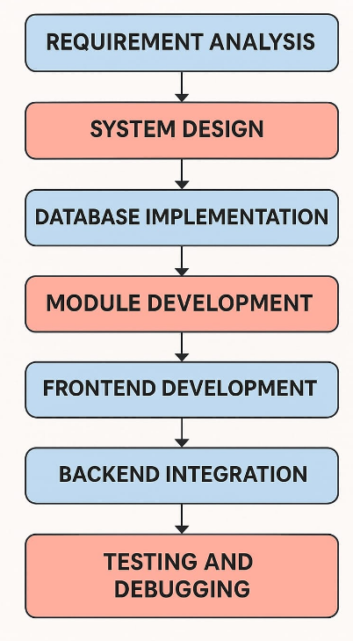

CHAPTER 3: MODULE DESCRIPICTION

3.1 User Management Module
This module handles user registration, authentication, and profile management. It allows users to create accounts, log in, update their profiles, and manage their preferences. Admins can manage user roles and permissions.

3.2 Book Catalog Module
The Book Catalog Module provides a comprehensive database of books available for the club. It includes features for adding, editing, and deleting book entries, as well as categorizing books by genre, author, and publication date. Users can search for books and view detailed information.

3.3 Club Management Module
This module facilitates the creation and management of book clubs. Users can create new clubs, join existing ones, and manage club settings. It includes features for scheduling meetings, setting club rules, and managing membership.

3.4 Reading Schedule Module
The Reading Schedule Module allows clubs to create and manage reading schedules. Users can propose books for reading, vote on selections, and view the reading timeline. It helps keep members informed about upcoming readings and deadlines.

3.5 Discussion Forum Module
This module provides a platform for members to discuss books and share insights. It includes features for creating discussion threads, posting comments, and moderating conversations. Users can engage in meaningful discussions related to the current reading material.

3.6 Notification and Alerts Module
The Notification and Alerts Module keeps users informed about important updates, such as new book selections, upcoming meetings, and discussion posts. Users can customize their notification preferences to receive alerts via email or in-app notifications.

3.7 Reports and Analytics Module
This module generates reports and analytics related to club activities. It can provide insights into reading trends, member participation, and book ratings. Admins can use this data to make informed decisions about future readings and club activities.

3.8 Feedback and Review Module
The Feedback and Review Module allows users to submit reviews and feedback on books they have read. This feature encourages engagement and helps other members make informed choices about their reading selections. Admins can moderate reviews to ensure appropriateness.

These modules collectively enhance the functionality and user experience of a Book Club Management System, making it easier for members to engage with books and each other.

CHAPTER 4: CONCLUSION & FUTURE SCOPE

Conclusion
The Book Club Management System is designed to streamline the organization and management of book clubs, enhancing the reading experience for members. By integrating various modules such as User Management, Book Catalog, and Discussion Forum, the system fosters a collaborative environment where members can share their love for reading. The features provided by the system not only facilitate efficient management of club activities but also encourage active participation and engagement among members. Overall, the system aims to create a vibrant community of readers, making book discussions more accessible and enjoyable
.Future Scope
- Mobile Application Development: Creating a mobile app version of the system can provide users with on-the-go access to their book clubs, notifications, and discussions, increasing participation and convenience.
- Integration with E-Book Platforms: Collaborating with e-book platforms to allow users to access and read books directly through the system can enhance the reading experience and make it easier for members to obtain reading materials.
- Advanced Analytics: Implementing more sophisticated analytics tools can provide deeper insights into user behavior, reading preferences, and engagement levels, allowing for more tailored recommendations and club activities.
- Social Media Integration: Allowing users to share their reading experiences and book reviews on social media platforms can help promote the book club and attract new members.
- Gamification Features: Introducing gamification elements, such as badges, leaderboards, and reading challenges, can motivate members to participate more actively and enhance their overall experience.
- Multilingual Support: Expanding the system to support multiple languages can make it accessible to a broader audience, fostering a more diverse community of readers.
- Virtual Events and Author Interactions: Hosting virtual events, such as author Q&A sessions or online book readings, can enrich the club experience and provide members with unique opportunities to engage with authors and fellow readers.

CHAPTER 5: APPENDIX A - SOURCE CODE

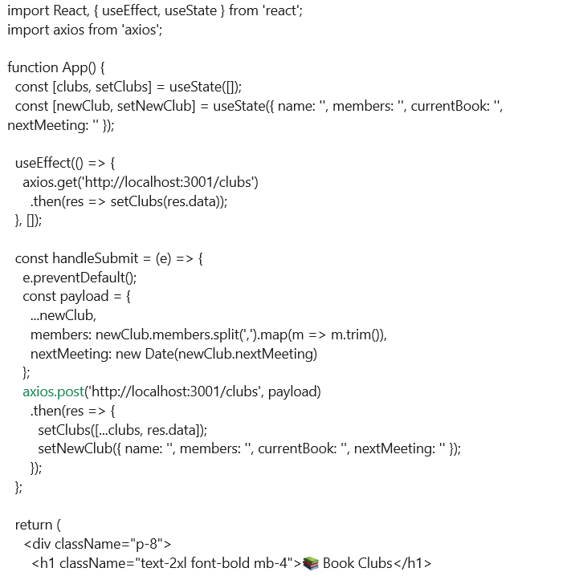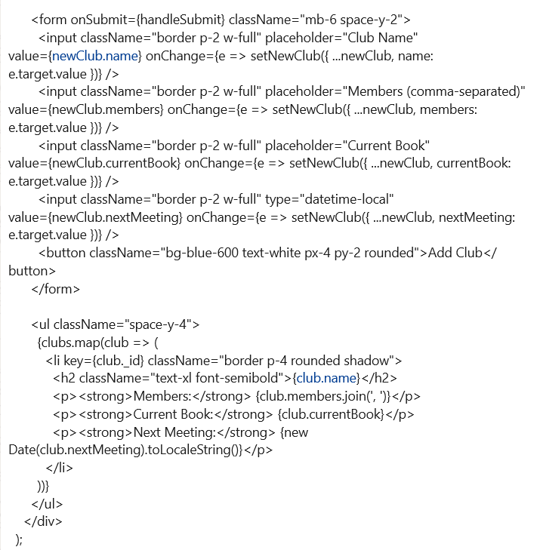


APPENDIX B - SCREENSHOTS
STEP 1:

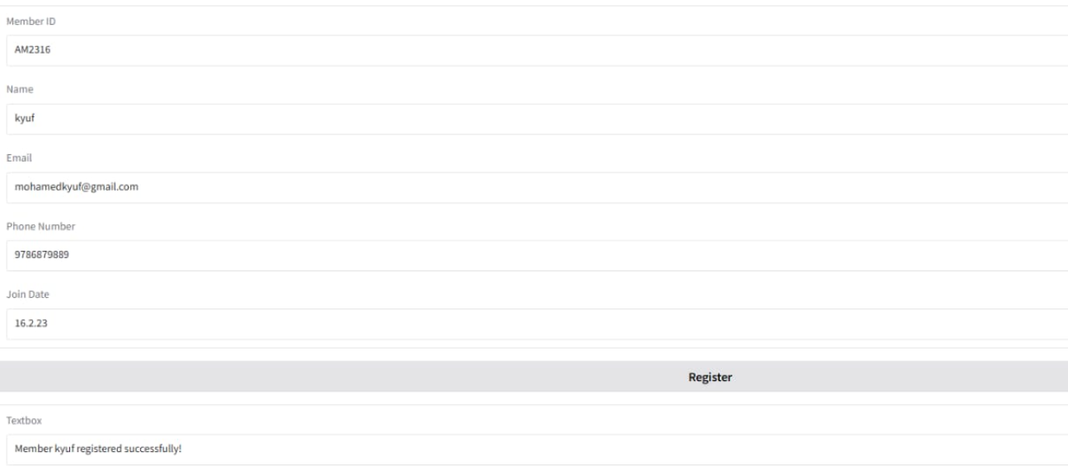

STEP 2:
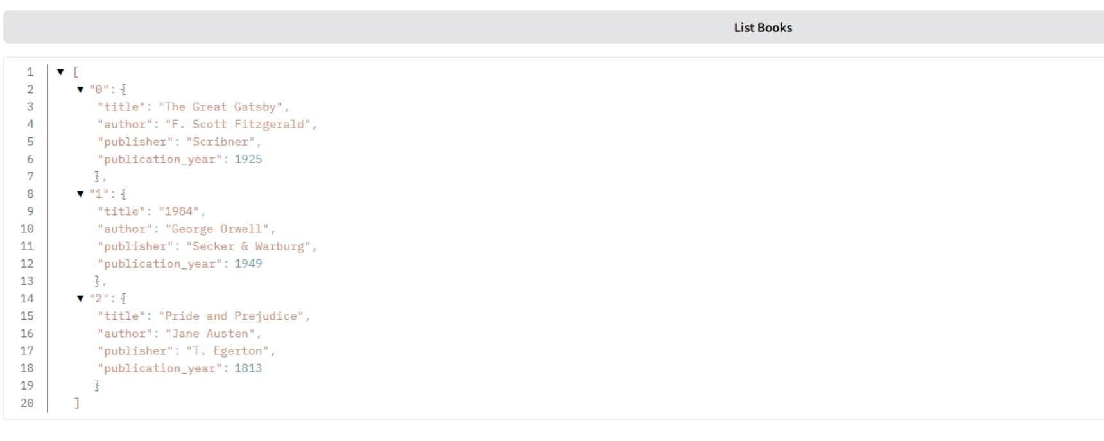

STEP 3:

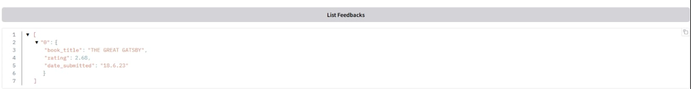

STEP 4:
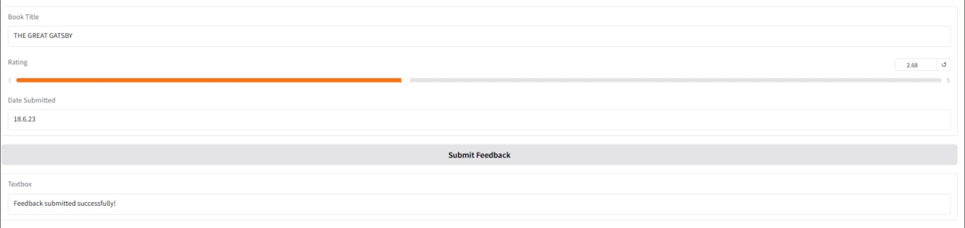
REFERENCES
Frontend
- React Docs: https://reactjs.org/docs/getting-started.html
- Tailwind CSS Docs: https://tailwindcss.com/docs
- Axios (HTTP client): https://axios-http.com/docs/intro
Backend
- Express.js: https://expressjs.com/
- Mongoose (MongoDB ODM): https://mongoosejs.com/
- CORS Middleware: https://expressjs.com/en/resources/middleware/cors.html
Database
- MongoDB Docs: https://www.mongodb.com/docs/manual/
- Installing MongoDB Locally: https://www.mongodb.com/docs/manual/installation/

